**Research**

Social media surrounds us and is apart of everyone's life more or less and the user base is growing year by year.

Here is the most up to date list of monthly active users for the top social networking sites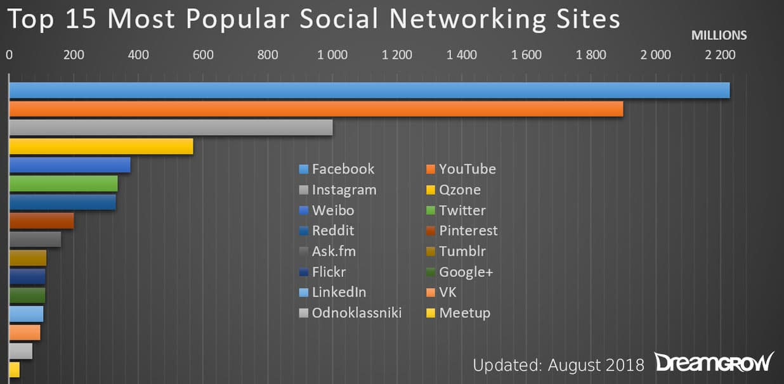

As you can see facebook is by far the most popular social media of choice closely followed by YouTube.

* Facebook has updated its monthly active user numbers to 2.23 billion in June.
* Youtube measures logged-in users, and is getting closer and closer to Facebook with 1.9 billion.
* Twitter reported 336 million active monthly users in its last quarterly report. Twitter also managed to post its first-ever quarterly profit.
* VK reached 97 million monthly active users
* Reddit adds users and displays 300 million users on their website.

Facebook jumped by 100 million monthly active users from 2.13 billion in December 2017 to 2.23 billion as of June 30, 2018. The rate of growth seems to continue at 15 million active users per month.

Another visualization to put into perspective how dominant facebook and youtube are. Instagram which was bought by facebook in 3rd place and it seems reddit and twitter are battling for the 4th spot.

Platforms like Qzone and VK are made popular by non western states such as China and Russia.

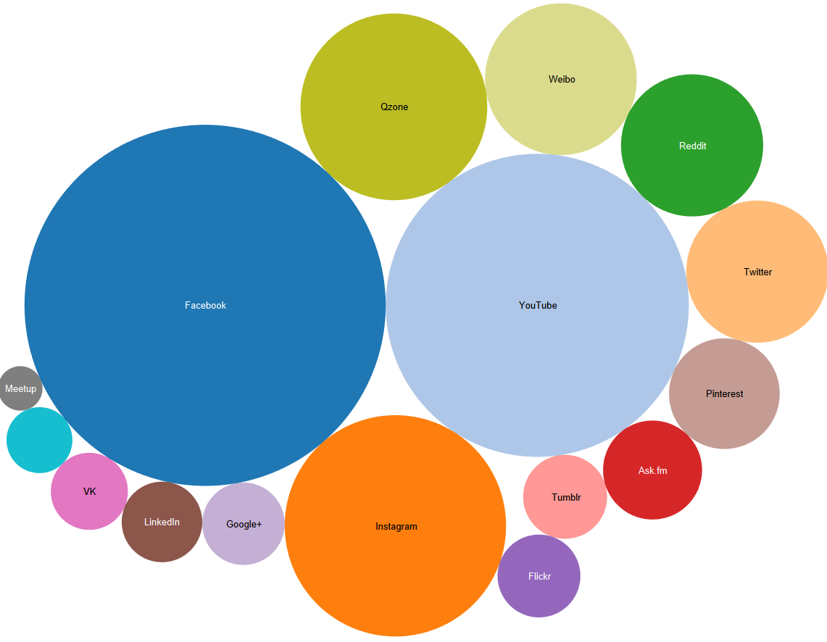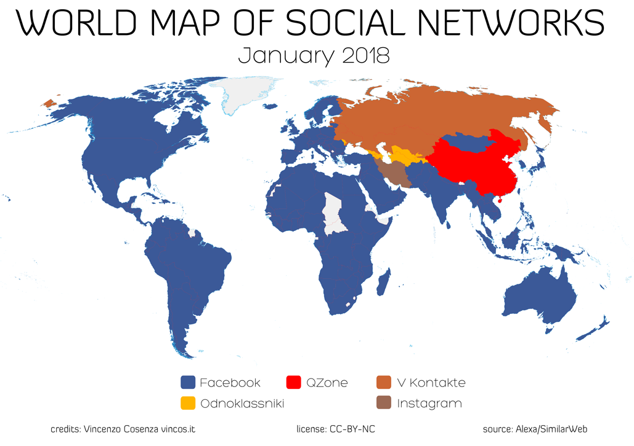

Italian writer, blogger, and photographer Vincenzo Cosenza has put together a visualization showing the most popular social networks around the world. The world map of social networks 2018 uses the latest traffic data from 2018.

Facebook is clearly in control of a great deal of the worlds social media with its reach expanding across Africa, Middle east and the pacific region.

With a user base of 2.2 billion and growing, the social media world map will probably look even bluer next year.

Notably, Facebook has now also swallowed up Japan. The remaining pockets of resistance are Russia and China.

In countries such as Japan twitter is ranked second because of its anonymity feature. It is also ranked second here in the UK.

We will focus on twitter within our project, logging users in via their face with recognition software. We are currently deciding on how to visualise the information we access when logged into a users profile

Bibliography

Dreamgrow.com. (2018). [online] Available at: https://www.dreamgrow.com/top-15-most-popular-social-networking-sites/ [Accessed 1 Dec. 2018].

Library, C. (2018). *Facebook Fast Facts*. [online] CNN. Available at: https://edition.cnn.com/2014/02/11/world/facebook-fast-facts/index.html [Accessed 3 Dec. 2018].